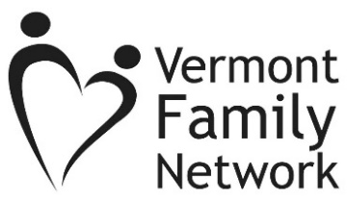 VFN confidential Fax: (802) 876-6291
or email to: info@vtfn.org
From: Click to add name
To: VFN Family Support
Date: Click to enter a date.

Family Information
Parent/Caregiver Name: Click to enter name
Phone Number: Click to enter phone number.
Email: Click to enter email.
Preferred contact method: ☐ Email ☐Phone
Child’s Age Click to enter Child’s Age (optional) Diagnosis: Click to enter Diagnosis (optional)

Reason(s) for referral (descriptions on next page)
☐ Parent Match  ☐ Funding  ☐ Sibshops  ☐ Educational Support/Parental Rights  ☐ Navigating Mental Health Systems | ☐ Health-Related Questions  ☐ Transition to Adult Services  ☐ Community Resources  ☐ Support/Recreational Groups  ☐ Other (please describe below)
Additional Information
Click to enter additional information.
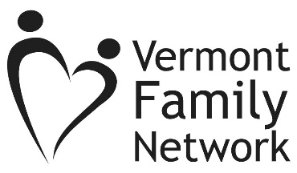

Parent Match Program: Talking on the phone with a parent who has “been there” can offer a source of empathy, hope, encouragement, and problem solving. We connect families of children with special needs with other families for support and information. Parents should never feel alone!
Funding: We can help find potential funding opportunities to cover medical needs not covered by insurance.
SibShops: SibShops are fun events for children and youth ages 6+, who have a brother or sister with special health care needs. Sibshops meet once a month in Chittenden County during the school year and events are co-facilitated by VFN and the Howard Center, with support from the Vermont Department of Health: Children with Special Health Needs. Each get-together includes activities, games, crafts, food, SibChat, and lots of fun!
Educational Support/Parental Rights: Our education support staff can help you navigate the school system, explain your rights as a parent, and help you plan and prepare for school meetings.
Navigating Mental Health Systems: Speak with a mental health support consultant about coordinating a collaborative meeting between education, mental health, and other service providers, to wrap your family with supports specific to your family and child’s needs.
Health-Related Questions: Our health support staff provides families and individuals with the support, connections, and information they need to make informed decisions and choices about their health care. We can answer questions about health insurance and Medicaid eligibility, help you better advocate for your child in healthcare settings, find relevant resources and supports, and more.
Transition to Adult Services: Planning early for the transition from home and high school, to living and working in the community helps families to be better prepared for what lies ahead. Our family support consultants can explain transition planning in high school, and adult services and supports.
Community Resources: We are happy to connect you with resources in the community to assist your family, from basic needs to a specific service.
Support/Recreational Groups: We maintain a list of support groups, camps, and other recreational opportunities for children and youth with special health needs, and their families.
Other: We’re here to listen and help with any needs or concerns you have about you or your child’s health, education, or well-being. We are parents of children with special health needs or disabilities and understand the challenges and gifts our children offer.

