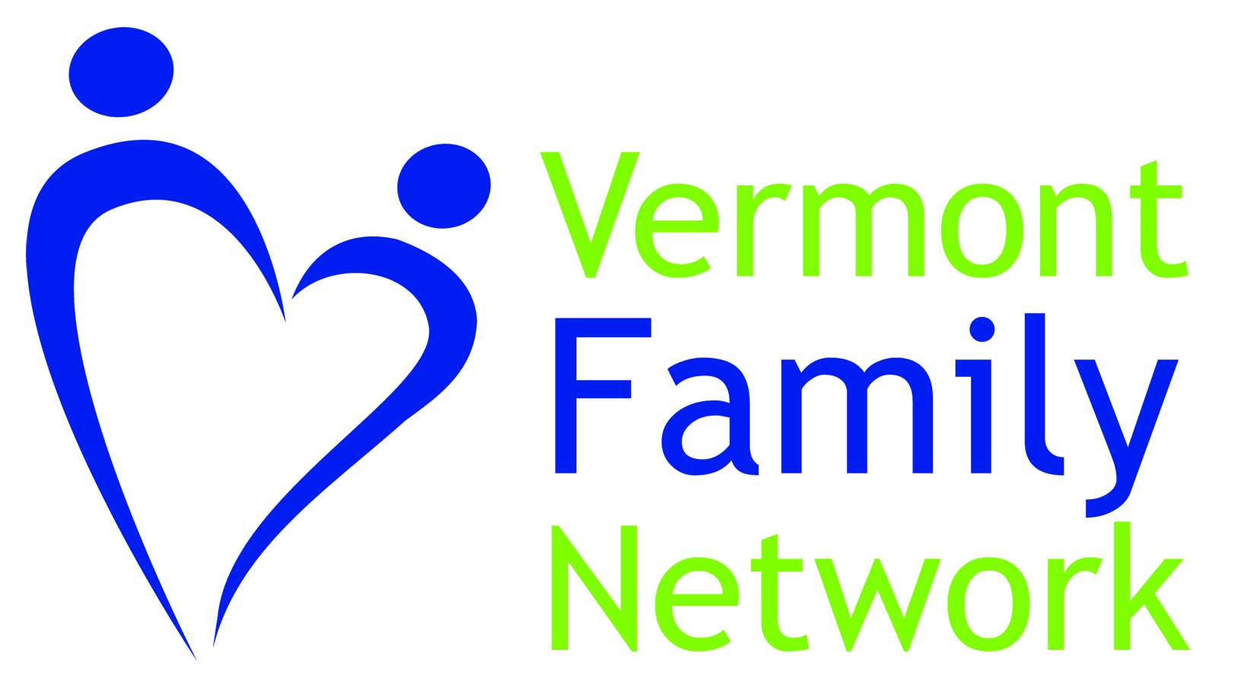 Autism Flutie Fund Application
Parents of children (birth to age 22) with an autism diagnosis may request up to $200 per year to help purchase equipment, therapeutic services, attend an autism-related event, caregiver respite or childcare, or for a summer camp.
Parent’s Name |  |  | Enter name
Mailing address |  |  | Enter here
County |  |  | Enter here
Phone number |  |  | Enter here
E-mail | Enter here
Child’s name with Autism |  |  |  | Enter here |  | Age | Enter here
Date of Birth |  | Enter here
Sibling(s) name, age and birthdate |  |  |  |  | Enter here

Our Federal grant requires we collect and report demographic information.
I identify as (check all that apply)
Asian Black/African White Hispanic/Latino Native American
Pacific Islander Prefer not to answer Other
Click Here to Respond

Please describe your request. What do you plan to purchase with the funds? Please be specific with details, including dates, locations, description of equipment, therapy, or name of a summer camp etc.

If awarded this money, what will change for you or your family? What are some specific benefits your child and/or family will experience from this funding?
Click here to respond

Anticipated total cost of request. If more than $200 how will you pay for the rest?
Click here to respond

In your own words, tell us what this funding means to you and your family. Is there anything else you would like to say about this Flutie Foundation opportunity?
Click here to respond

Signature |  | Sign here
Date | Enter here

